

**REPORT FOR EDURESOLVE COMMUNITY ENGAGEMENT PROGRAM**

**Date**

Saturday, 7th September 2024

**Location**

Auta Balefi Kodape Community, Karu LGA, Nasarawa State

**Facilitators**

Jethro

Margaret

Racheal

Gabriel

Emmanuella

**Table of Contents**

**Executive Summary** 3

**Key Activities** 3

**Outcomes** 3

**Introduction** 5

**Background Information** 5

**Objectives** 5

**Overview of the Agenda** 5

Methodology 6

Session Summaries 7

**Creating an Action Plan** 9

**Key Outcomes** 9

Feedback and Evaluation 11

Conclusion 12

**Next Steps** 12

**Appendices** 13

**1.** Attendance 13

**2.** **Images of the sections** 13

Budget…………………………………………………………………………………………………………………………………………………..14

# **Executive Summary**

The Community Engagement was held on Saturday, 7th September 2022, in Auta Balefi Kodape Community, Karu LGA, Nasarawa State. The Community Engagement aimed to foster community development through inclusive education and to identify and address the needs and challenges faced by students with learning difficulties.

The primary objective was to increase awareness and understanding of inclusive education, identify community needs and challenges, and develop collaborative solutions and action plans. The Community Engagement also aimed to strengthen community partnerships and ensure continued engagement and commitment to action.

## **Key Activities**

1. **Welcome and Introduction:** Facilitated by Jethro, this session included a brief introduction of the facilitators, an overview of the Community Engagement’s purpose, and an icebreaker activity to help participants get to know each other.
2. **Discussion Sessions:**
   * **Session 1:** Led by Margaret, focused on setting the context of inclusive education and community development.
   * **Session 2:** Facilitated by Racheal, involved small group discussions to identify the specific needs and challenges faced by students with learning difficulties.
   * **Session 3:** Conducted by Gabriel, focused on brainstorming collaborative solutions and action planning.
   * **Session 4:** Led by Emmanuella, involved creating a concrete action plan based on the solutions discussed.
3. **Closing Remarks and Refreshments:** Jethro concluded the Community Engagement with closing remarks, followed by a group photograph and refreshments.

## **Outcomes**

* **Increased Awareness and Understanding:** Participants gained a deeper understanding of the importance of inclusive education and its impact on community development.
* **Identification of Community Needs and Challenges:** The Community Engagement successfully identified the specific needs and challenges faced by students with learning difficulties in the community.
* **Commitment to Action:** Participants expressed a strong commitment to taking actionable steps to support inclusive education.
* **Strengthened Community Partnerships:** The Community Engagement fostered stronger partnerships among community members, local organizations, and schools.
* **Collaborative Solutions and Action Planning:** Concrete solutions and action plans were developed to address the identified challenges.

The Community Engagement was a significant step towards creating a more inclusive and supportive community for students with learning difficulties. The collaborative efforts and commitment of all participants will contribute to the overall development and cohesion of the Auta Balefi Kodape Community.

# **Introduction**

## **Background Information**

The Community Engagement was organized to address the pressing need for inclusive education within the Auta Balefi Kodape Community in Karu LGA, Nasarawa State. Inclusive education is essential for creating a fair and equitable society, ensuring that all students, regardless of their abilities or disabilities, have access to quality education and opportunities to succeed. The Community Engagement was held on Saturday, 7th September 2022, and brought together community members, educators, and local organizations to discuss and develop strategies for supporting students with learning difficulties.

## **Objectives**

The primary objectives of the Community Engagement were:

1. **Increase Awareness and Understanding:** To educate participants about the importance of inclusive education and its impact on community development.
2. **Identify Community Needs and Challenges:** To identify the specific needs and challenges faced by students with learning difficulties in the community.
3. **Develop Collaborative Solutions and Action Plans:** To brainstorm and develop actionable solutions and strategies to support inclusive education.
4. **Strengthen Community Partnerships:** To foster stronger partnerships among community members, local organizations, and schools.
5. **Ensure Follow-Up and Continued Engagement:** To establish plans for follow-up activities and continued engagement to ensure the sustainability of the initiatives.

## **Overview of the Agenda**

The Community Engagement followed a structured agenda to ensure a comprehensive and engaging discussion on inclusive education and community development. The agenda included the following key activities:

1. **Welcome and Introduction:** Facilitated by Jethro, this session included a brief introduction of the facilitators, an overview of the Community Engagement’s purpose, and an icebreaker activity to help participants get to know each other.
2. **Discussion Session 1:** Led by Margaret, focused on setting the context of inclusive education and community development.
3. **Discussion Session 2:** Facilitated by Racheal, involved small group discussions to identify the specific needs and challenges faced by students with learning difficulties.
4. **Discussion Session 3:** Conducted by Gabriel, focused on brainstorming collaborative solutions and action planning.
5. **Discussion Session 4:** Led by Emmanuella, involved creating a concrete action plan based on the solutions discussed.
6. **Closing Remarks, Group Photograph, and Refreshments:** Jethro concluded the Community Engagement with closing remarks, followed by a group photograph and refreshments.

# **Methodology**

The **Community Engagement Community Engagement** employed a variety of methodologies to facilitate discussions and activities, ensuring active participation and engagement from all attendees. These methods were carefully chosen to achieve the Community Engagement’s objectives of increasing awareness, identifying community needs, developing solutions, and fostering partnerships.

**1. Individual Work**

The Community Engagement began with individual work during the welcome and introduction session. Participants were asked to introduce themselves and share personal insights. This method helped participants feel comfortable and engaged from the start, setting a positive tone for the Community Engagement. It also allowed facilitators to establish a connection with each participant.

**2. Class Activities**

Several sessions involved class activities where participants engaged in discussions and interactive presentations. Class activities, such as the discussion on inclusive education led by Margaret, provided a platform for sharing knowledge and experiences. These activities encouraged participants to think critically about the importance of inclusive education and its impact on community development.

**3. Group Activities**

Small group discussions were a key component of the Community Engagement, particularly during the session on identifying community needs and challenges facilitated by Racheal. Group activities allowed participants to collaborate and share diverse perspectives. This method was effective in identifying specific needs and challenges faced by students with learning difficulties, as it encouraged open dialogue and collective problem-solving.

**4. Presentations**

Presentations were used to convey important information and set the context for discussions. For example, Margaret’s presentation on inclusive education provided a foundation for subsequent discussions. Presentations helped to structure the Community Engagement and ensure that key information was communicated clearly. They also served as a starting point for deeper discussions and reflections.

**6. Brainstorming Sessions**

Collaborative brainstorming sessions were conducted to develop solutions and action plans. Gabriel facilitated a session focused on generating ideas for supporting students with learning difficulties. Brainstorming sessions fostered creativity and encouraged participants to think of both immediate actions and long-term strategies. This method was instrumental in developing practical and innovative solutions.

**7. Action Planning**

The Community Engagement concluded with a session on creating a concrete action plan, led by Emmanuella. Participants worked together to outline specific steps, assign responsibilities. Action planning ensured that the ideas generated during the Community Engagement were translated into actionable steps. This method provided a clear roadmap for implementation and encouraged commitment from participants.

By employing these diverse methodologies, the Community Engagement successfully engaged participants, facilitated meaningful discussions, and achieved its objectives of increasing awareness, identifying needs, developing solutions, and fostering community partnerships.

# **Session Summaries**

**Welcome and Introduction**

**Objective:** To introduce the facilitators and provide an overview of the Community Engagement’s purpose and objectives.

**Activities:** Jethro facilitated this session, starting with a brief introduction of the facilitators and an icebreaker activity. Participants paired up, shared personal details, and introduced their partners to the group.

**Key Points:** The introduction set a positive tone for the Community Engagement, helping participants feel comfortable and engaged. The icebreaker activity encouraged interaction and established a friendly atmosphere.

**Setting the Context: Inclusive Education and Community Development**

**Objective:** To provide participants with an understanding of the importance of inclusive education and its impact on community development.

**Activities:** Margaret led this session with a presentation on inclusive education, sharing local statistics and a real-life example to illustrate the benefits. Participants were then prompted to discuss why inclusive education is important for their community.

**Key Points:**

* + Inclusive education promotes equality and reduces discrimination.
  + It empowers students with learning difficulties and benefits the entire community by fostering a culture of acceptance.
  + Local statistics highlighted the need for inclusive education, with only 30% of children with learning difficulties having access to such programs.
  + The story of Amina, a student with dyslexia, demonstrated the transformative power of inclusive education.

**Identifying Community Needs and Challenges**

**Objective:** To identify the specific needs and challenges faced by students with learning difficulties in the community.

**Activities:** Racheal facilitated small group discussions, where participants were divided into groups to respond to three guiding questions. Each group appointed a spokesperson to share their findings.

**Key Points:**

* + **Group 1:**
    - **Challenges:** Lack of support from parents, overcrowded classrooms, faulty foundations.
    - **Impacts:** Increase in school dropouts, children becoming hawkers, loss of confidence in abilities.
    - **Resources:** Some schools have assistant teachers, government intervention projects.
  + **Group 2:**
    - **Challenges:** Inferiority complex, slow learning despite support, fear, lack of assistance.
    - **Impacts:** Low self-esteem, timidity, school dropouts.
    - **Resources:** Encouragement and love, prayers, learning materials, trained teachers, conducive environment.

**Collaborative Solutions and Action Planning**

**Objective:** To brainstorm potential solutions and develop both immediate actions and long-term strategies.

**Activities:** Gabriel facilitated a brainstorming session where participants discussed the roles of the community, government, NGOs, and schools in supporting students with learning difficulties.

**Key Points**

* + **Community:**
    - Community initiatives.
    - Organize workshops such as the Community engagement forum where Parents will be trained to understand the Value of Education
    - Individual sponsorship through scholarships.
  + **Government:**
    - Provide materials.
    - Insist on using qualified teachers in both government and private schools.
    - Initiate policies to regulate the employability of teachers.
    - Train teachers to handle learning difficulties.
    - Supervision and regulation of school openings.
  + **NGOs:**
    - Proper monitoring and evaluation after implementing support projects.
  + **Schools:**
    - Adequate security to regulate loitering during school hours.
    - Appropriate school locations.
    - Affordable school fees.
    - Employment of trained and qualified teachers.

**Creating an Action Plan**

**Objective:** To develop a concrete action plan based on the solutions discussed.

**Activities:** Emmanuella led this session, guiding participants through the process of identifying key solutions, defining specific actions, assigning responsible parties, and setting timelines.

**Key Points**

* + Participants identified key solutions such as organizing community workshops and establishing peer mentoring programs.
  + Specific actions were defined for each solution.
  + The action plan provided a clear roadmap for implementation, ensuring that the initiatives are well-organized and achievable.

**Closing Remarks, Group Photograph, and Refreshments**

**Objective:** To conclude the Community Engagement with closing remarks and provide an opportunity for networking.

**Activities:** Jethro delivered closing remarks, thanking participants for their contributions. A group photograph was taken, followed by refreshments.

**Key Points:** The closing remarks emphasized the importance of continued engagement and collaboration. The group photograph and refreshments provided a relaxed environment for informal networking.

# **Key Outcomes**

The **Community Engagement** achieved several significant outcomes, reflecting the collective efforts and active participation of all attendees. These outcomes are crucial for fostering inclusive education and community development in Auta Balefi Kodape Community.

**1. Increased Awareness and Understanding:**

* **Outcome:** Participants gained a deeper understanding of the importance of inclusive education and its impact on community development.
* **Details:** Through presentations and discussions, participants learned about the benefits of inclusive education, local statistics, and real-life examples. This increased awareness is expected to drive more informed and supportive actions within the community.

**2. Identification of Community Needs and Challenges:**

* **Outcome:** The Community Engagement successfully identified the specific needs and challenges faced by students with learning difficulties.
* **Details:** Small group discussions facilitated by Racheal highlighted key challenges such as lack of parental support, overcrowded classrooms, and faulty educational foundations. The impact of these challenges, including increased school dropouts and low self-esteem among students, was also discussed. This identification process is essential for developing targeted interventions.

**3. Commitment to Action:**

* **Outcome:** Participants expressed a strong commitment to taking actionable steps to support inclusive education.
* **Details:** The collaborative brainstorming sessions led by Gabriel and the action planning session facilitated by Emmanuella resulted in concrete action plans. Participants committed to specific roles and responsibilities, ensuring that the initiatives discussed will be implemented effectively.

**4. Strengthened Community Partnerships:**

* **Outcome:** The Community Engagement fostered stronger partnerships among community members, local organizations, and schools.
* **Details:** The discussions and collaborative activities encouraged participants to work together towards common goals. Partnerships were strengthened through shared commitments and the development of joint action plans. This collective approach is vital for sustaining long-term support for inclusive education.

**5. Collaborative Solutions and Action Planning:**

**Outcome:** Concrete solutions and action plans were developed to address the identified challenges.

**Details:** Participants brainstormed and outlined specific actions, responsible parties, and timelines for implementation. Key solutions included organizing community workshops, establishing peer mentoring programs, and advocating for policy changes. These plans provide a clear roadmap for addressing the needs of students with learning difficulties.

The Community Engagement’s outcomes demonstrate significant progress in promoting inclusive education and community development. The increased awareness, identification of needs, commitment to action, strengthened partnerships, and collaborative solutions developed during the Community Engagement will contribute to creating a more inclusive and supportive environment for all students in Auta Balefi Kodape Community.

# **Feedback and Evaluation**

**Summary of Participant Feedback:** As the Community Engagement concluded, participants expressed their satisfaction and appreciation for the event. They highlighted several aspects of the Community Engagement that they found particularly valuable and provided constructive feedback for future sessions.

**Effectiveness of the Community Engagement:**

* **Positive Reception:** Participants were happy with the Community Engagement’s organization and content. They appreciated the interactive nature of the sessions and the opportunity to engage in meaningful discussions.
* **Increased Awareness:** Many participants noted that they gained a deeper understanding of inclusive education and its importance for community development. The real-life examples and local statistics shared during the sessions were particularly impactful.
* **Practical Insights:** The Community Engagement provided practical insights and actionable steps that participants felt they could implement in their own contexts. The collaborative brainstorming and action planning sessions were especially well-received.

**What Participants Learned:**

* **Inclusive Education:** Participants learned about the benefits of inclusive education, including how it promotes equality, empowers students with learning difficulties, and strengthens community cohesion.
* **Community Needs and Challenges:** The discussions helped participants identify specific needs and challenges faced by students with learning difficulties in their community. They gained a better understanding of the impact of these challenges on the broader community.
* **Collaborative Solutions:** The brainstorming sessions equipped participants with ideas for immediate actions and long-term strategies to support inclusive education. They learned about the roles that different stakeholders, such as the community, government, NGOs, and schools, can play in this effort.

**Suggestions for Improvement:**

* **More Sessions:** Participants expressed a strong desire for additional sessions. They felt that more frequent Community Engagements would help sustain momentum and allow for continued learning and collaboration.
* **Broader Participation:** There was a suggestion to invite more community members, including parents, teachers, and local leaders, to future Community Engagements. Participants believed that broader participation would enhance the impact of the discussions and action plans.
* **Publicity and Outreach:** Participants offered to help with publicity for future sessions, indicating their willingness to invite other community members and spread awareness about the importance of inclusive education.

**Commitment to Future Engagement:**

* **Follow-Up Sessions:** Participants were enthusiastic about the idea of follow-up sessions to review progress, share updates, and continue developing solutions. They emphasized the importance of maintaining ongoing engagement and collaboration.
* **Publicity Efforts:** Many participants volunteered to assist with publicity efforts for future Community Engagements. They were eager to involve more community members and ensure that the message of inclusive education reaches a wider audience.

The feedback and evaluation from participants indicate that the Community Engagement was highly effective in achieving its objectives. The positive reception, increased awareness, practical insights, and commitment to future engagement highlight the Community Engagement’s impact on the community. The suggestions for improvement provide valuable guidance for planning future sessions, ensuring that they continue to meet the needs and expectations of the community.

# **Conclusion**

**Final Thoughts:** The **Community Engagement** held on **Saturday, 7th September 2022**, in **Auta Balefi Kodape Community, Karu LGA, Nasarawa State**, was a significant step towards fostering inclusive education and community development. The Community Engagement successfully increased awareness, identified community needs, developed collaborative solutions, and strengthened partnerships. The active participation and commitment of all attendees were instrumental in achieving these outcomes.

The discussions and activities highlighted the importance of inclusive education in creating a fair and equitable society. By addressing the needs of students with learning difficulties, we can build a stronger, more cohesive community. The Community Engagement’s outcomes provide a solid foundation for continued efforts to support inclusive education and community development.

**Next Steps**

To ensure the sustainability and effectiveness of the initiatives discussed during the Community Engagement, the following next steps have been outlined:

1. **Follow-Up Sessions:** Organize follow-up sessions to review progress, share updates, and continue developing solutions. These sessions will help maintain momentum and ensure ongoing engagement.
2. **Publicity and Outreach:** Increase publicity efforts to involve more community members, including parents, teachers, and local leaders. Participants have volunteered to assist with these efforts, ensuring broader participation and awareness.
3. **Strengthening Partnerships:** Continue to foster partnerships among community members, local organizations, schools, and government agencies. Collaborative efforts will be crucial in sustaining long-term support for inclusive education.
4. **Continuous Learning and Improvement:** Encourage continuous learning and improvement by incorporating feedback from participants and adapting strategies as needed. Regular evaluations and feedback sessions will help identify areas for enhancement.

# **Appendices**

1. Attendance

|  |  |  |
| --- | --- | --- |
| **SN** | **Name** | **Phone Number** |
| 1 | Happiness Austin | 07087905561 |
| 2 | Faith Ephraim | 0810400598 |
| 3 | Jummai Sabo | 07068151511 |
| 4 | Ann Ujah | 08053672793 |
| 5 | Jemima Dauda | 09044303148 |
| 6 | Alheri Gana Emmanuel | 08056833199 |
| 7 | Deborah Jethro | 07060967637 |
| 8 | Nenritmwa Joseph | 08031188055 |
| 9 | Mathias Evelyn |  |
| 10 | Oghumu Justice | 08022912766 |
| 11 | Nora Justice |  |
| 12 | Gabriel Micah | 08106331451 |
| 13 | Racheal Aziara | 08142461194 |
| 14 | Margaret James | 07037675722 |
| 15 | Emmanuella Y. Shehu | 08135326403 |
| 16 | Bature Jethro | 08065799035 |

1. **Images of the sections**

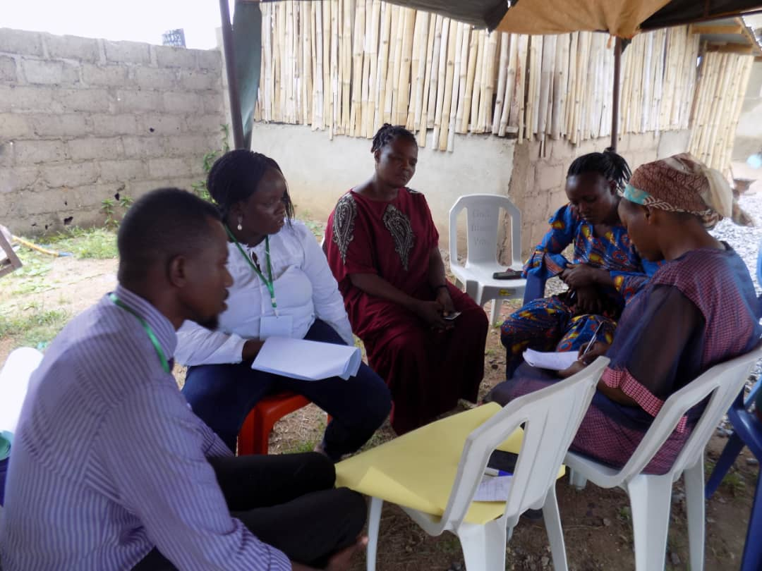

**Group 1 during Brainstorming session**

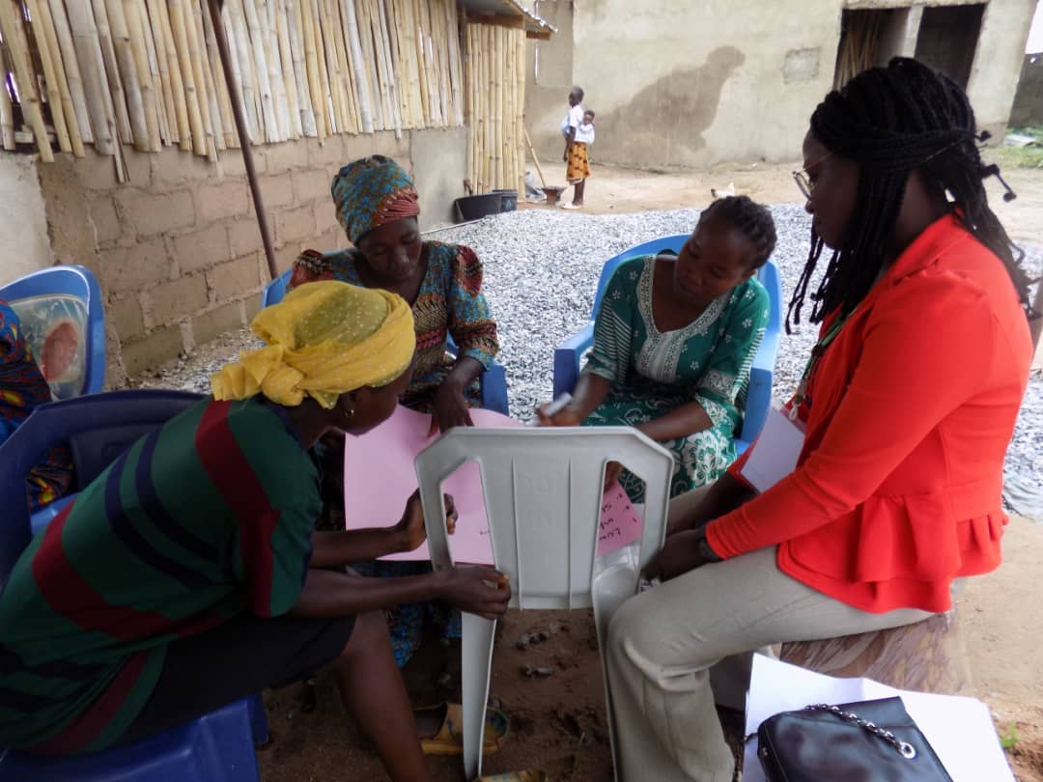

**Group 2 During Brainstorming session**

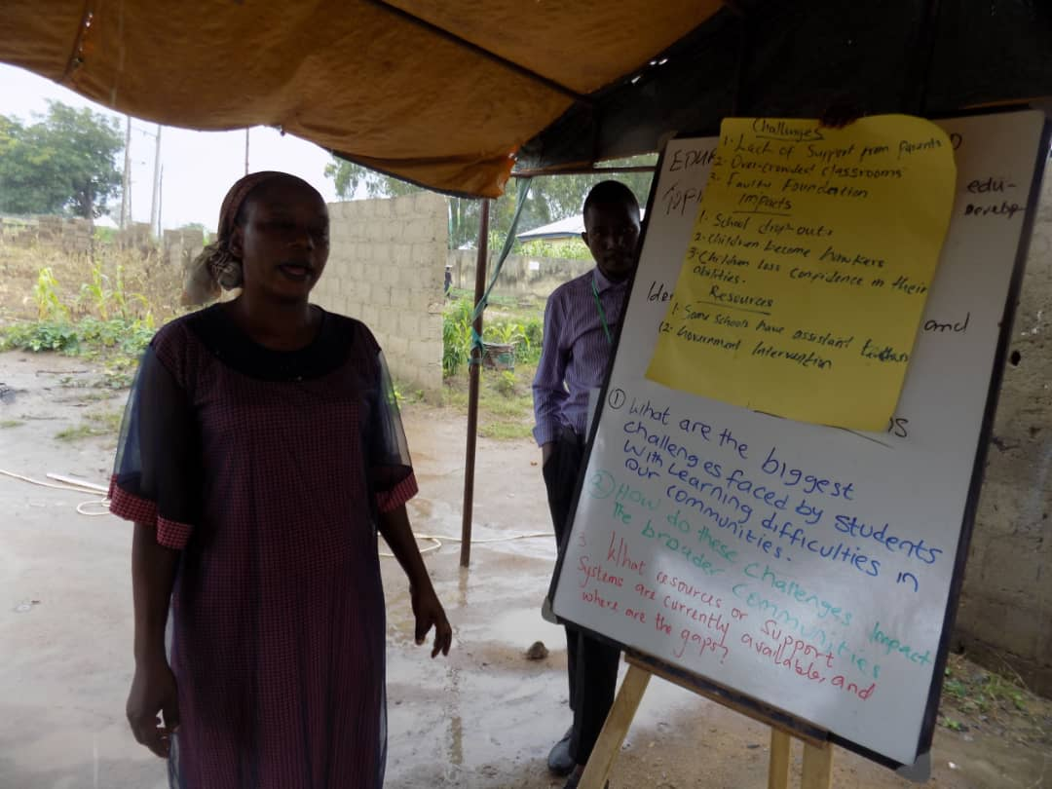

**Group Presentation**

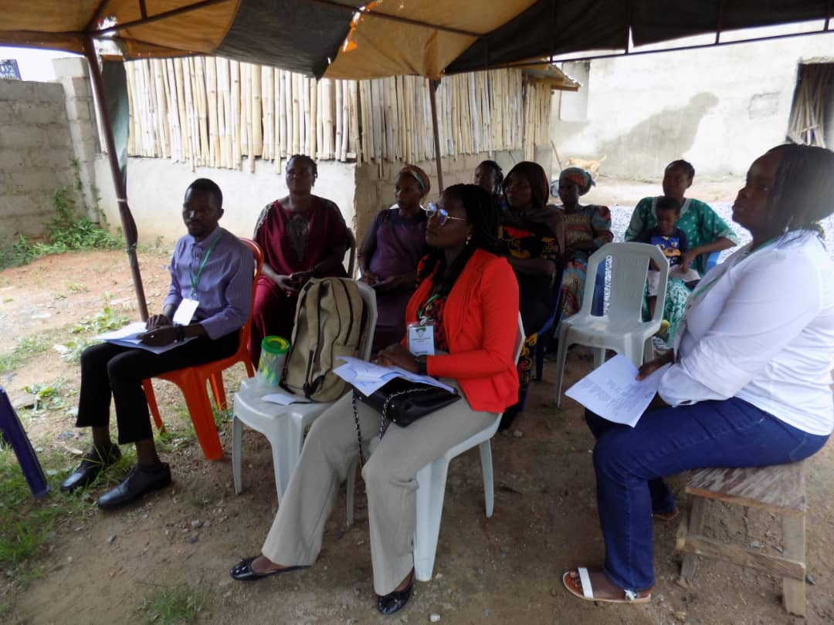

**In Class Session during Presentation**

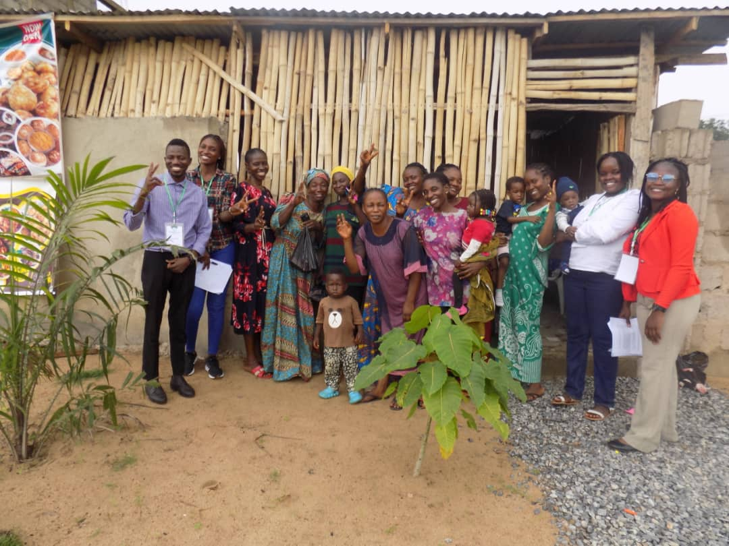

**Group Photo**